In Linux, the kill command (located inside the /bin/kill) can be defined as a built-in command. It is **used for manually terminating the processes**. The behaviour of the kill command is slightly different among the shells and the /bin/kill standalone executable.

It is used for manually terminating the processes. The behaviour of the kill command is slightly different among the shells and the ***/bin/kill*** standalone executable.

We can apply the type command for displaying every location on our system that is containing kill:

1. $ type -a kill

**-15** (**-TERM**).

The most widely applied signals are as follows:

* **HUP (1)-** It reloads a process.
* **KILL (9)-** It kills a process.
* **TERM (15)-** It stops a process gracefully.

We can use the kill command along with the **-l** option for getting the list of every available signal:

1. $ kill -l

These signals could be described in three different ways. These ways are listed below:

* By number (e.g. -6)
* Without SIG prefix (e.g. -kill)
* With SIG prefix (e.g. -SIGkill)

The below commands are similar to each other:

* $ kill -SIGHUP PID_NUMBER
* $ kill -HUP PID_NUMBER
* $ kill -1 PID_NUMBER

There are two commands used to kill a process: **kill – Kill a process by ID**. killall – Kill a process by name.

**Note:**

* Negative PID values are used to indicate the process group ID. If you pass a process group ID then all the process within that group will receive the signal.
* A PID of -1 is very special as it indicates all the processes except kill and init, which is the parent process of all processes on the system.
* To display a list of running processes use the command *ps* and this will show you running processes with their PID number. To specify which process should receive the kill signal we need to provide the PID.

**Syntax:**

$ps

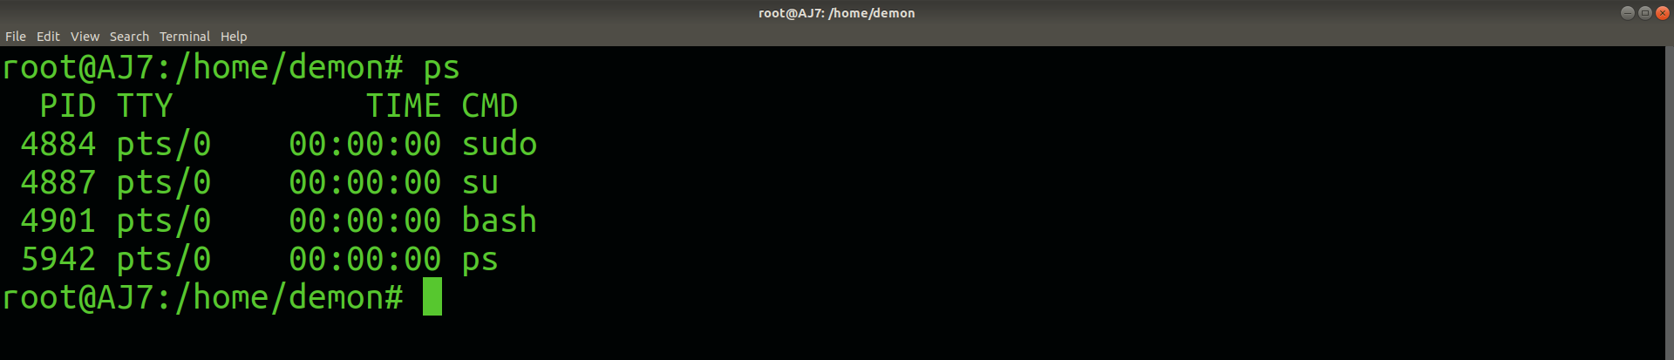

**2. kill pid :** To show how to use a *PID* with the *kill* command.

**Syntax:**

$kill pid

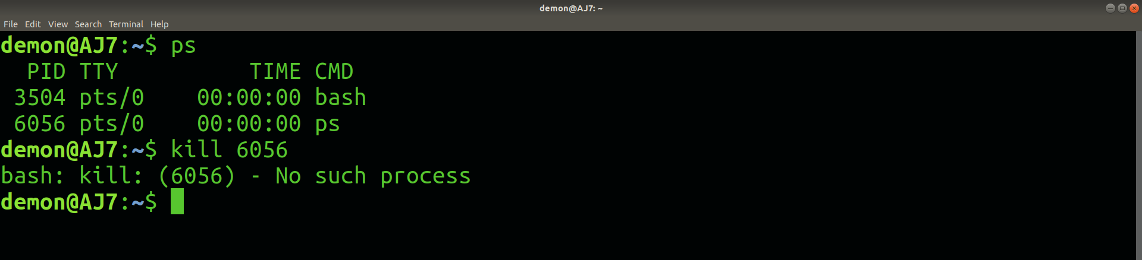

**3. kill -s :** To show how to send signal to processes.

**Syntax:**

kill {-signal | -s signal} pid

**4. kill -L :**This command is used to list available signals in a table format.

**Syntax:**

kill {-l | --list[=signal] | -L | --table}